Hello,
I hope you had a wonderful Thanksgiving holiday! For someone that didn’t grow up with turkey in his diet, I was shocked and relieved to find out how many other folks also share my skepticism of the white turkey meats… too easily dried out. Those machete-sized turkey legs at the fairs, however, are a whole different delicious story.
In last month’s Learning Vacuum email, I discussed the physics of volume expansion under vacuum for a sealed vessel application. However, when a vacuum pump is used in an application that’s open to atmosphere, a whole different set of physics principles and phenomenon comes into play.
A common application for Nash liquid ring vacuum pumps is dewatering of paper, carpet, extruded fiber, mined mineral, fabric, sugar, etc. These processes are typically done using a belt filter, drum filter, or vacuum slots at very close proximity to the product being dewatered. Vacuum is applied on one side of the product, while the other side of the product is exposed to atmosphere. The functional purpose of the vacuum is to create enough air velocity to mechanically strip the product of free water, or unbound moisture. This calls for the understanding of bound vs. unbound moisture.
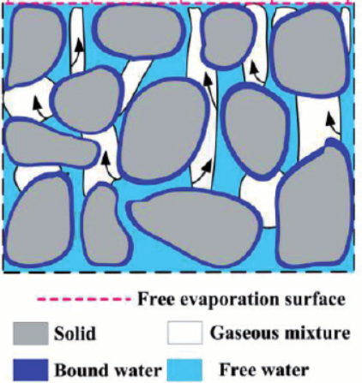
In illustration above, bound moisture is the water retained in small capillaries at solid surfaces as solutions in cells or fibers, it has lower vapor pressure than water at the same temperature; unbound moisture is any moisture other than the bound moisture and has the same vapor pressure as water. Imagine wringing a soaking wet towel. You can remove a lot of water from the towel, but no matter how hard you wring it or how long you leave it in the washer’s spin cycle, it will always remain damp. The water you remove from wringing is the unbound moisture, but fibers of the towel still trap some unbound moisture and all the bound moisture, keeping it damp. Further drying is needed to remove all moisture.
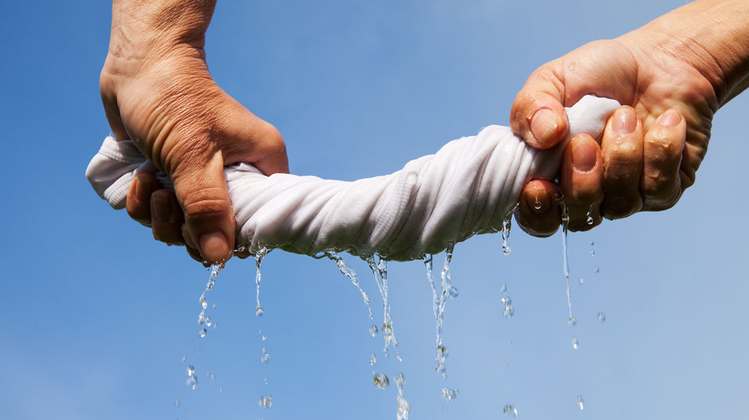
Years ago, E.W. Klein conducted a study aimed at identifying the percentage of bound moisture various carpet fibers can entrap. Below is a summarized result:
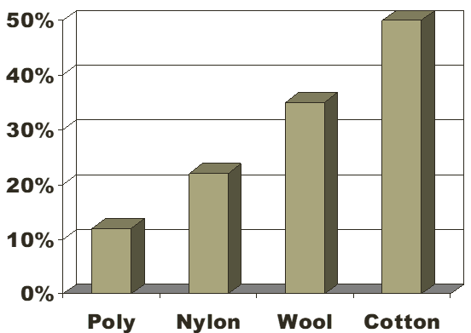
Bound moisture must work its way to the surface of the solids by capillary action or diffusion before it can evaporate and be removed. This can take some added effort and time. Coming from polyester extrusion background, I know too well of the challenges facing removing bound moisture from hygroscopic materials like PET or PETG before extrusion. That’s why we skipped the step of resin drying and regrind recrystallization, instead just pulled vacuum during extrusion using Nash LRVP to remove moisture in-process.
Removing unbound moisture using high air speed generated from vacuum is limited by the sonic velocity of air. Deeper vacuum does not always equal better drying. As vacuum level gets deeper, air velocity entering the pump increases as well. However, air velocity will approach up to 720 mph but not increase any further. This plateau would occur at around 16 in-Hg gauge vacuum depth. An earlier study done by E.W. Klein illustrated this phenomenon in plot below:
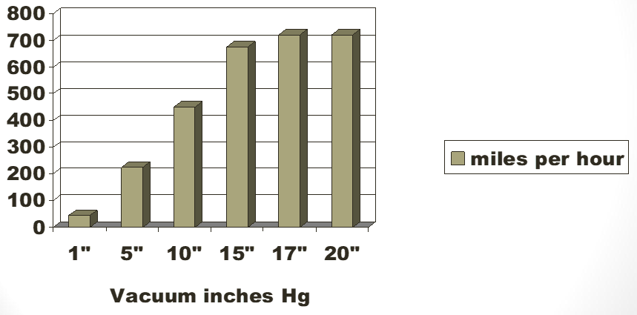
This study has helped many of our customers determine their most cost-effective vacuum depth to operate their Nash LRVP’s at. Further thermal drying is often used after the vacuum drying section of the process.
As always, I hope you find value in what I’ve shared. Please let me know if you have any specific topic you’d like me to discuss in future emails. Since I’ve been at E.W. Klein for a year now, I don’t think I can still claim to be the “new guy”, so I’ll just shorten these emails to Learning Vacuum emails.
Take care!

